1. Annual Maintenance Contract (AMC) and LLM Version Updates
Yes, an AMC can be offered to customers to maintain and upgrade the AI components of the DocuVault system.
Under AMC we can provide:
- LLM upgrades (for example upgrading from Queen 2.5 to newer models)
- Performance optimizations
- Security patches
- Retrieval improvements
- UI improvements
- Infrastructure monitoring and maintenance

Technical Clarification
The system does NOT train the LLM on customer documents.
Instead, it uses Retrieval Augmented Generation (RAG).

System Workflow
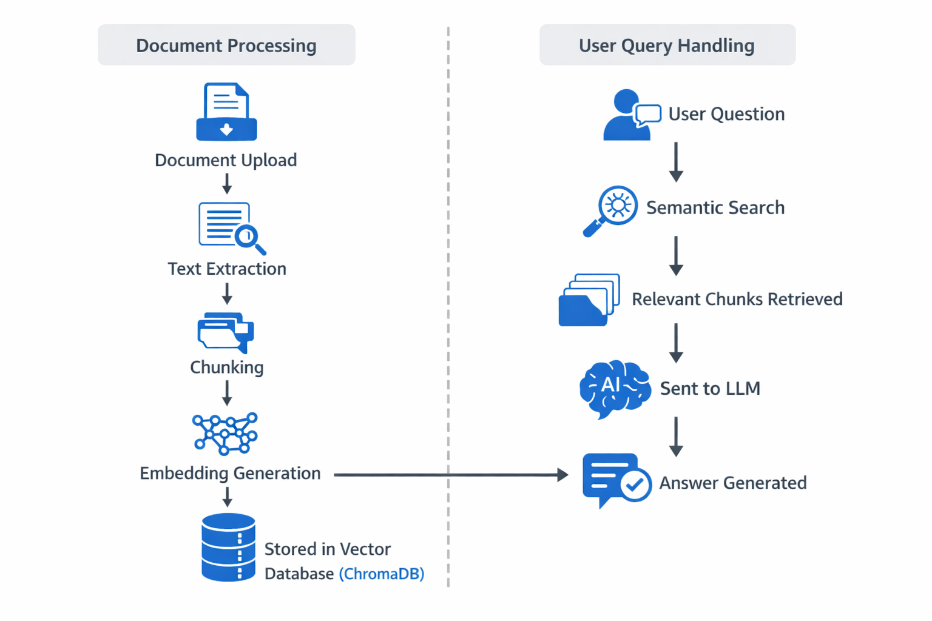
Because of this architecture:
- LLM upgrades DO NOT require retraining of documents
- Existing indexed documents continue working normally

When Re-Indexing Might Be Required

Reindexing is required only if we change the embedding model.
Example:
- Qwen3-Embedding → BGE-Large
- Sentence Transformers → OpenAI embeddings
In such cases embeddings are recomputed automatically, which is fast and can be handled under AMC.

2. Integration with On-Premise Email Systems
The system can integrate with customer email systems, but the LLM is not trained on emails. Instead emails are ingested and indexed so they become searchable.

Supported Email Systems
- Microsoft Outlook / Exchange, Microsoft 365, Gmail, IMAP servers, and on-premise enterprise mail servers.

Architecture

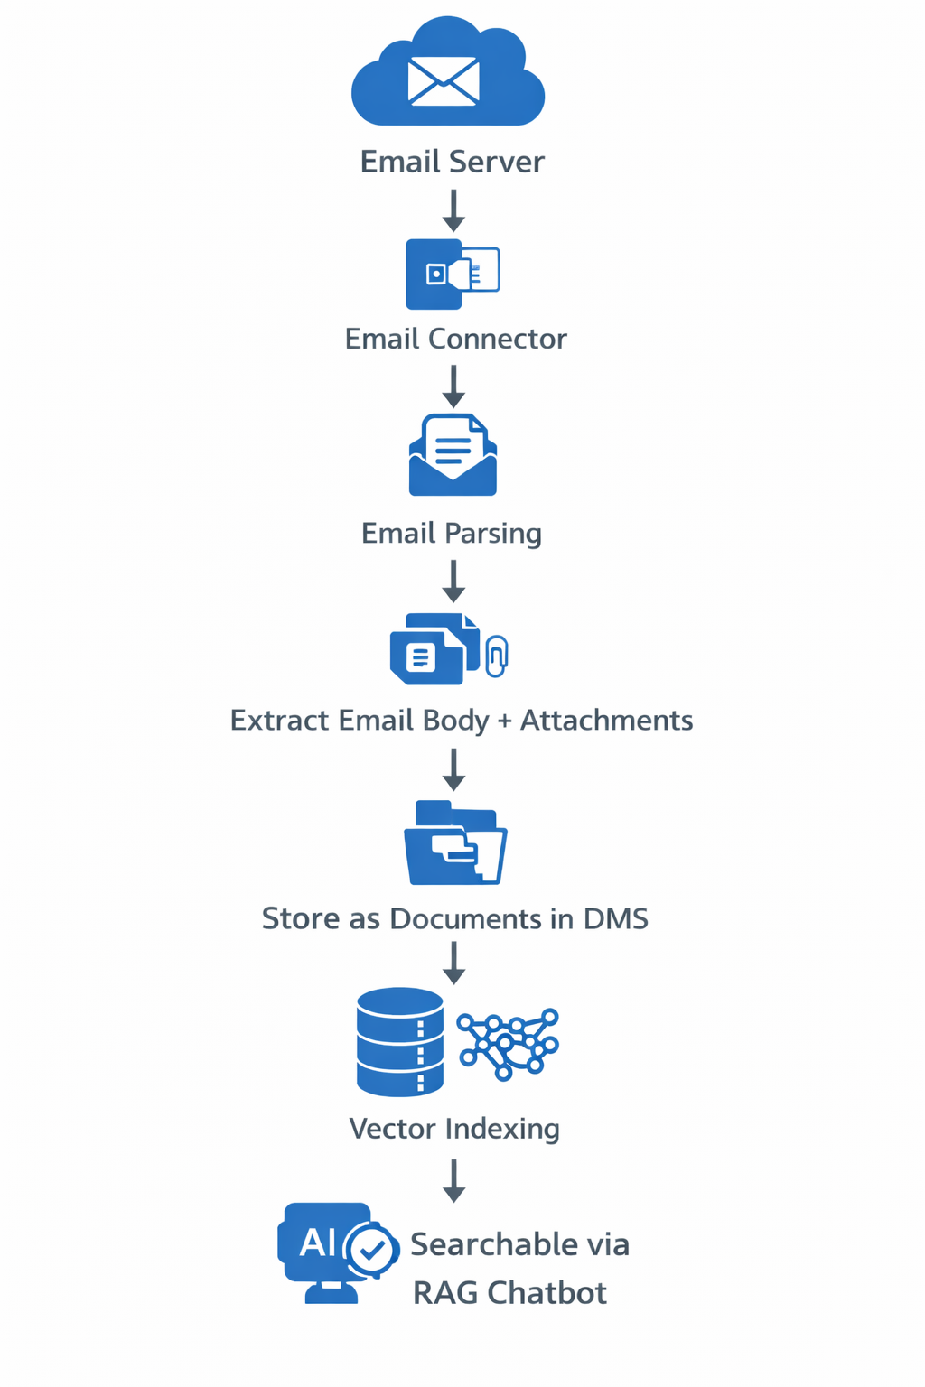

What Gets Indexed
- Email body text
- Attachments (PDF, Word, Excel, PPT)
- Metadata
  - sender
  - receiver
  - Subject & timestamp

Security
Role-based access ensures secure retrieval.
Example:
HR emails → HR users only
Finance emails → Finance users only
Users can ask:
“Show discussions about vendor contracts with ABC company.”
The system retrieves information from:
- documents
- attachments
- email conversations
3. Google Drive–Like Version Control Across LAN
A Google Drive–like experience can be implemented using a LAN Sync Connector.
Instead of manually uploading files, users save documents in a synchronized folder.

Architecture
User PC
↓
Synced Folder (DocuVault Sync)
↓
Background Sync Agent
↓
DocuVault Server
↓
Version Control + Indexing

Features
- Automatic document synchronization
- Version tracking
- Timestamp and user tracking
- Rollback to previous versions

Example Version History
proposal.docx v1
proposal.docx v2
proposal.docx v3

LAN Deployment Model
DocuVault Server (Django + RAG)
│
├── PC1 Sync Agent
├── PC2 Sync Agent
└── PC3 Sync Agent

Advantages
- No manual uploads
- Automatic versioning
- Instant AI indexing
- Enterprise-ready deployment

Implementation Options
- Desktop sync agent (recommended)
- Network shared drive monitoring
- Google Drive–style desktop client

4. Does the LLM Train Automatically When Documents Are Uploaded?
No. The LLM does not train on uploaded documents.
Instead, the system performs document indexing.

Workflow
Upload Document
↓
Text Extraction
↓
Document Chunking
↓
Embedding Generation
↓
Stored in Vector Database
↓
Document becomes searchable
This process is called indexing, not training.

Components in DocuVault
The RAG system uses modules like:
- document_processor.py
- embeddings.py
- vector_store.py
- retriever.py

Typical Workflow
Upload document
↓
Click Index for RAG
↓
Embedding created
↓
Stored in ChromaDB
↓
Chatbot can answer questions

Enhancement
The system can be configured to auto-index documents on upload so that they become searchable instantly.

Summary for Client
Question | Answer
AMC for LLM upgrades | Supported
Retraining required | Not required
Email integration | Possible
Google Drive-like version control | Possible
LLM training on upload | Not required (RAG indexing used)

BigQuery is designed for structured data analytics using SQL queries, whereas our DocuVault system is designed for semantic search and AI-based question answering over unstructured documents such as PDFs, emails, and reports. Instead of querying tables, our system converts documents into vector embeddings and retrieves relevant content using semantic similarity before generating answers with an LLM. Therefore, the two systems serve different purposes and are complementary rather than competing technologies.

